**FUNDAMENTALS OF DATA ANALYTICS WITH TABLEAU**

**PROJECT TITLE:** Unlocking insights into the global air transportation network

NAAN MUHALVAN PROJECT

ID: NM2023TMID20383

**TEAM MEMBERS**:

1.K.PERIYANAYAKI

2.M.ABSAL NISHA

3.S.JANANI

4.T.AARTHI

5.A.ARTHI

**DEPARTMENT OF MATHEMATICS**

SREE SEVUGAN ANNAMALAI ARTS AND SCIENCE COLLEGE

DEVAKOTTAI

INTRODUCTION:

Welcome to our groundbreaking Airlines Transportation project! Our initiative aims to revolutionize air travel by integrating cutting-edge technologies, enhancing passenger experience, and optimizing operational efficiency. From advanced booking systems to smart in-flight services, we're committed to elevating every aspect of the aviation industry. Join us on this journey towards a seamless, connected, and eco-friendly future of air transportation.

USES:

In essence, unlocking insights into the global air transportation network empowers stakeholders to make informed decisions, enhance efficiency, and contribute to the overall improvement of the aviation ecosystem.

EMPATHY:

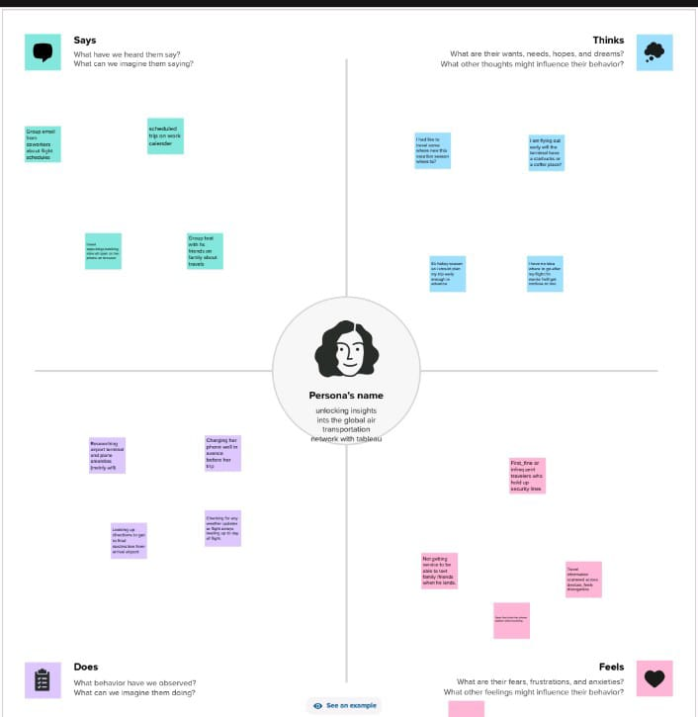

First we make a empathy map for a group idea .To create a empathy map from Mural web site and logic with email account and search the templates that you Wanted to create.

BRAINSTORMING MAP:

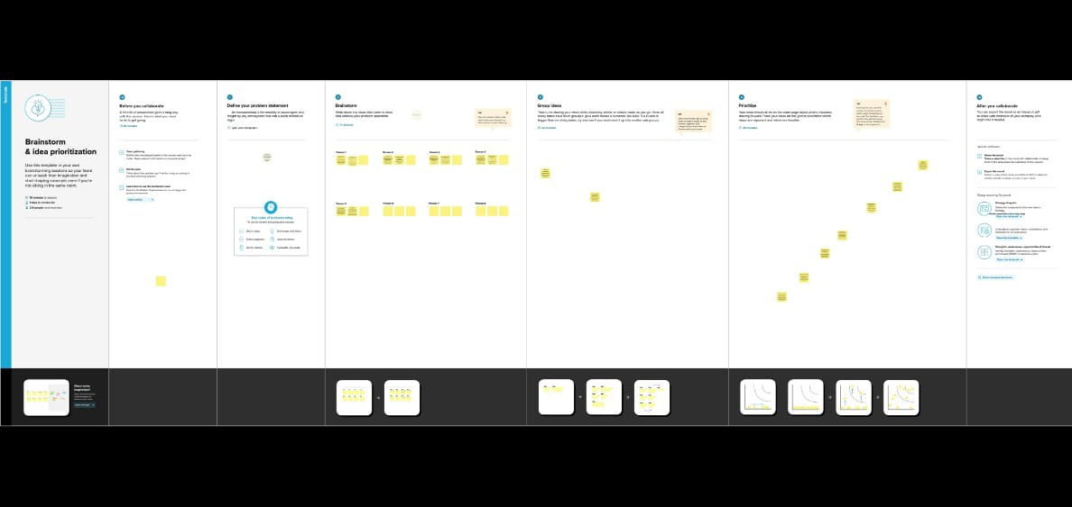

Then make a brainstorm map with mural website. I brainstorm we discussed the Define problem and understand the problem. First we have defined what are the Problems and types in the question box. Then it is a group idea and write in the Box as person1, person2 and person 3. Now three person give different idea for The same problem. Take best three idea and type in last box.

PROCEDURE FOR TABLEAU PROJECT:

Before opening the tableau desktop we had download the dataset for your project .after download the dataset we open the tableau desktop After opening the selected link connect to data, select the “more” option and select the dataset.It opens in the data source, now we arranged the data and select the “extract” option for the better performance for you analysis.

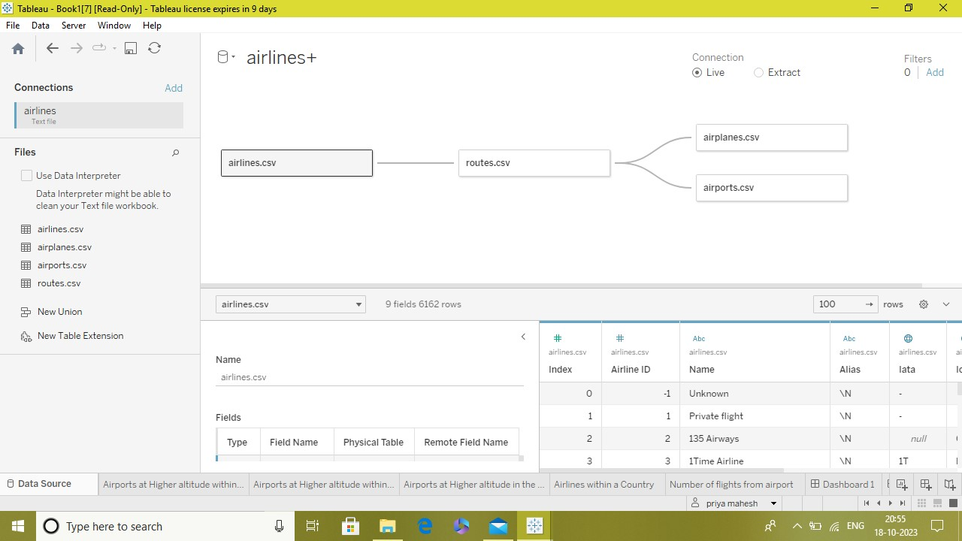

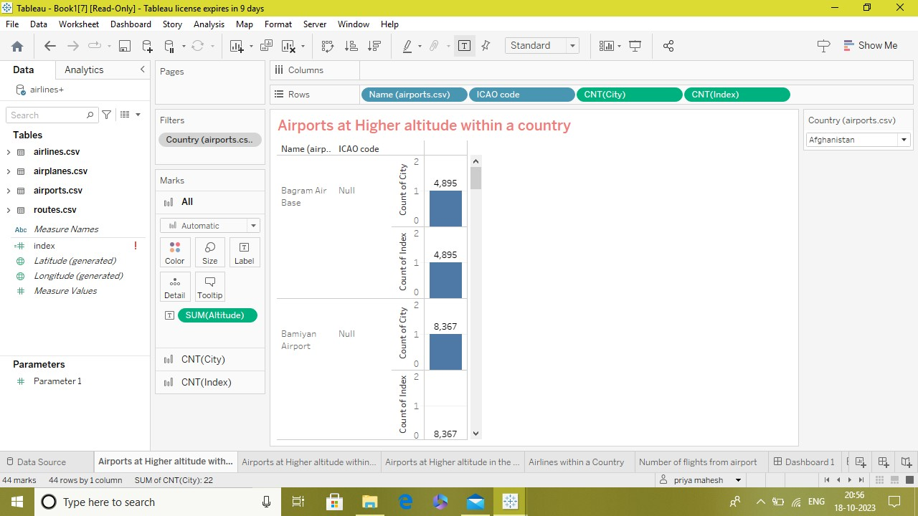

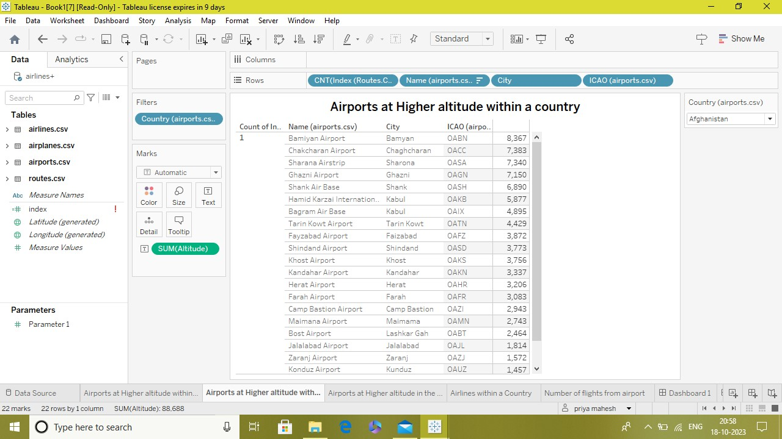

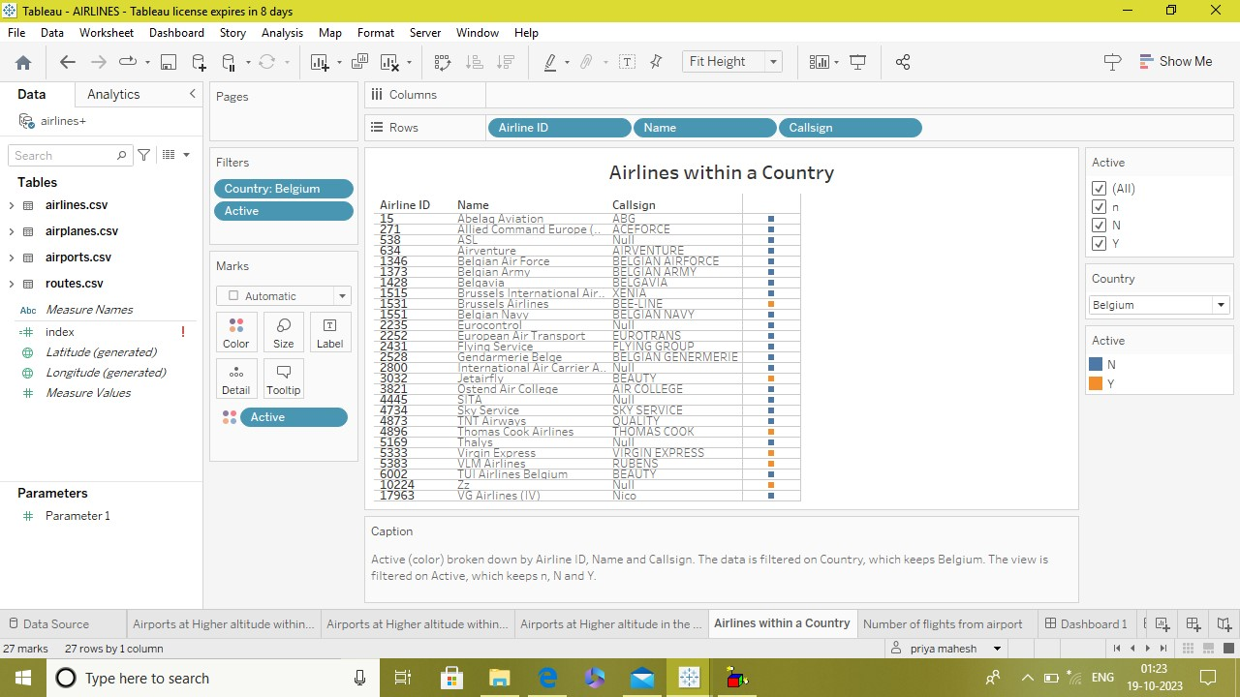

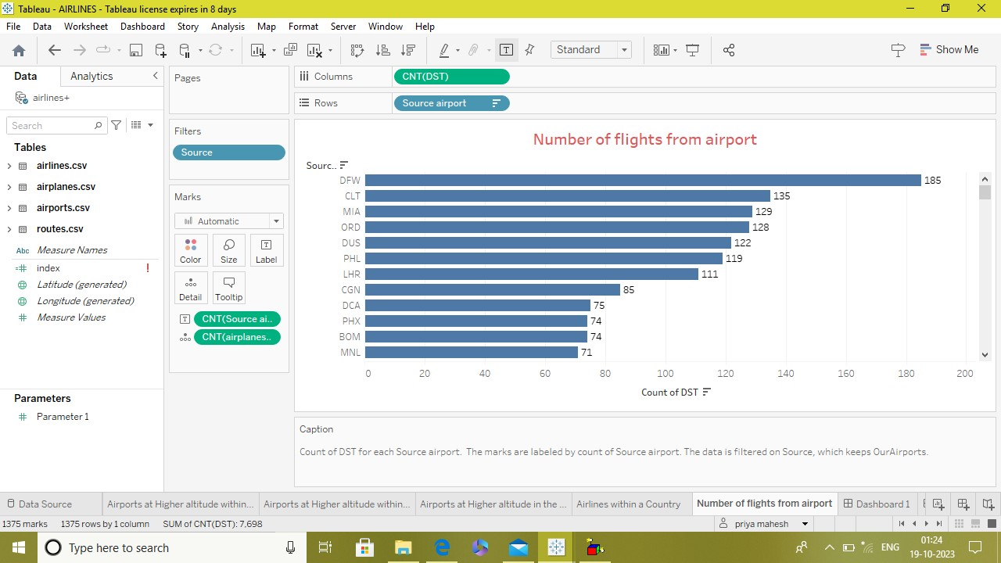

RESULT:

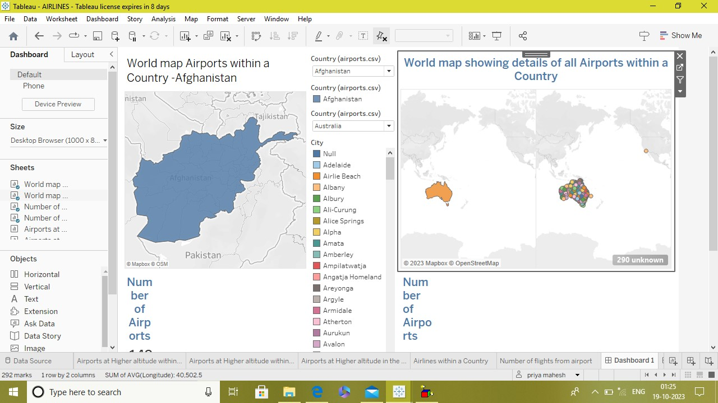

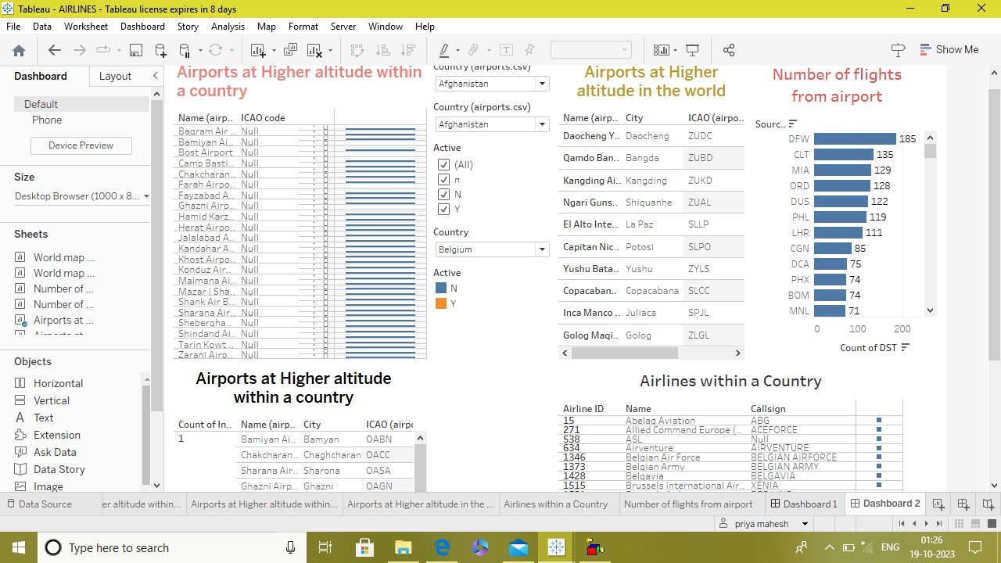

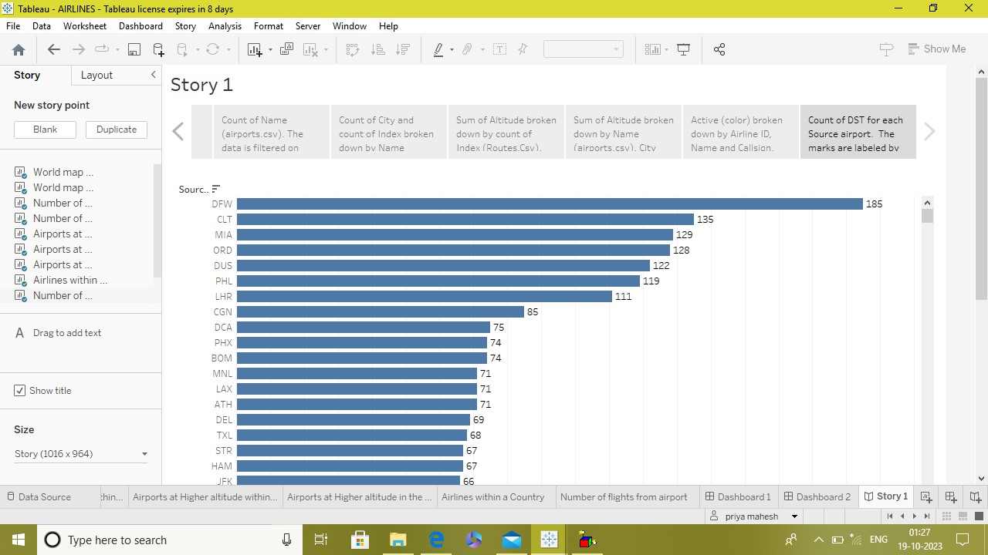

ADVANTAGE:

1. Operational Efficiency
2. Fuel Efficiency
3. Predictive Maintenance
4. Enhanced Safety
5. Improved Passenger Experience

DISAVANTAGE:

1. Privacy Concerns
2. Privacy Concerns Risk
3. Overreliance on Technology
4. Misuse of Information

APPLICATION:

1. Optimizing Routes and Operations
2. Enhancing Passenger Experience
3. Predictive Maintenance
4. Emergency Response Planning

CONCLUSION:

In summary, unlocking insights into the global air transportation network is crucial for optimizing efficiency, enhancing safety measures, and addressing environmental impacts. The analysis of data and patterns within this network can lead to informed decision-making, improved connectivity, and a more sustainable future for air travel worldwide.

FUTURE SCOPE:

The future scope of unlocking insights into the global air transportation network is vast, with ongoing advancements and emerging trends that promise transformative.